Journal Question

​For Week 2, complete your learning journal reflection.

Learning Journal Title: Chapter 4
Learning Journal Topics:
Healthcare Quality and Data Quality
Value Based Health & Meaningful Use

Explore Process Step
Stat Explore Node
Graph Explore Node

Modify Process Step
Impute Node
Interactive Binning Node
Replacement Node
Transform Variable Node​
* I’ve attached chapter 4.

Here is my answer that I did for week 1 :

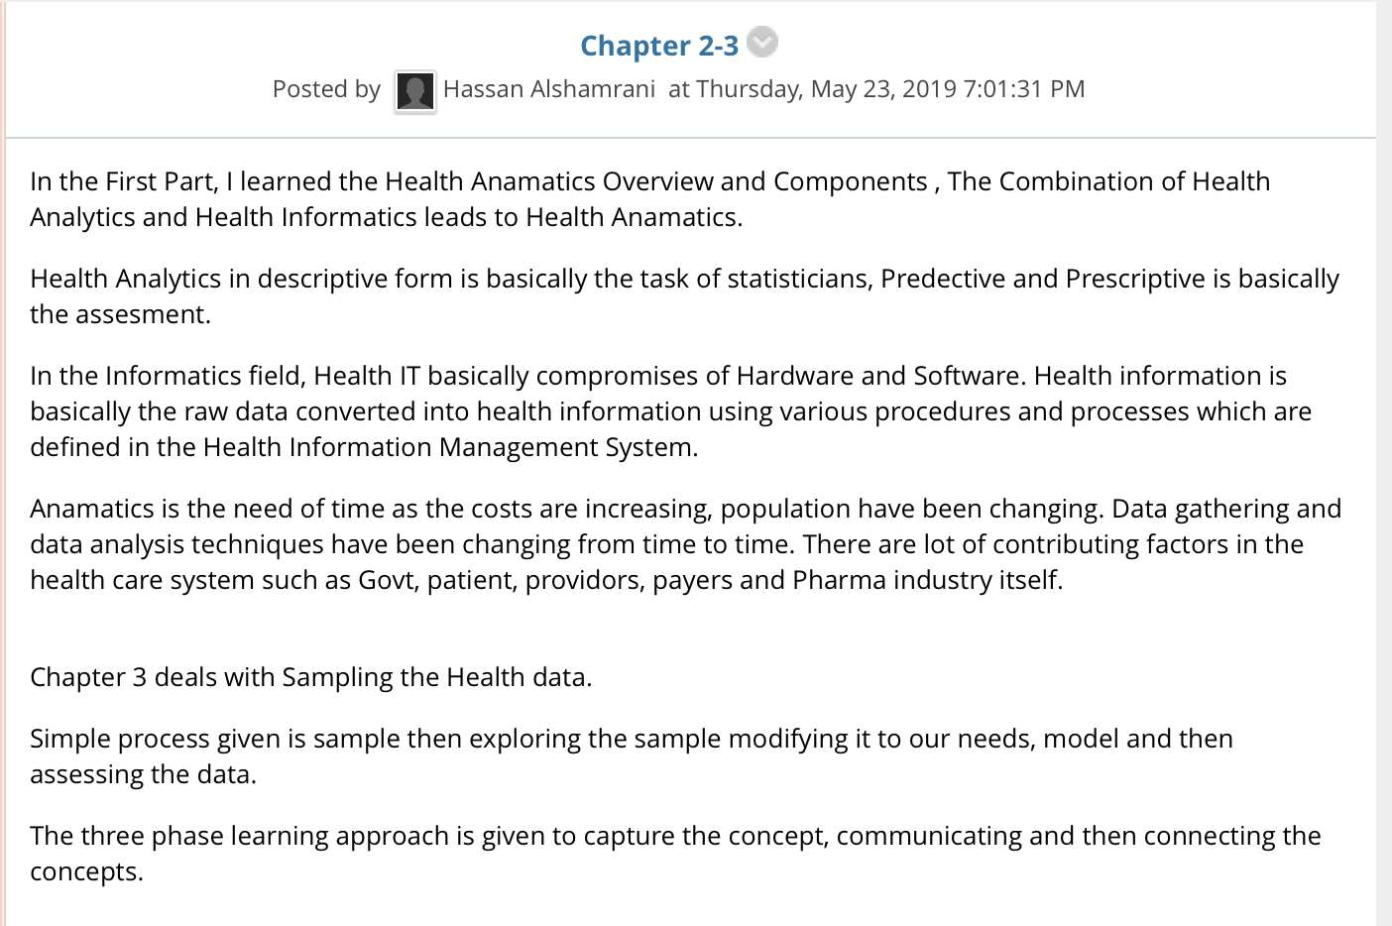

I just show you how it looks like.

